Real Time Events
- Create Integration Class
- Create Service Package
- Create Rest Service
- Create Activity
- Create Single Page Property
- Create Properties on Integration Class
- Create Action
- Add Eligibility in Action
- Create New Real Time Event / Use Existing Events
- Create Email Treatment (Internal) / Use Existing Treatment
- Add Treatment in Action
- Add Offer Flow
- Run the Data Flow as ProcessFromEventSource
- Run the Service
- Verify Dataset as CDHEventSource
- Run the Dataset as pxInteractionHistory

Use Case 1: Online Transaction
Use Case 2: ATM Transaction / Withdraw money

Create Integration Class
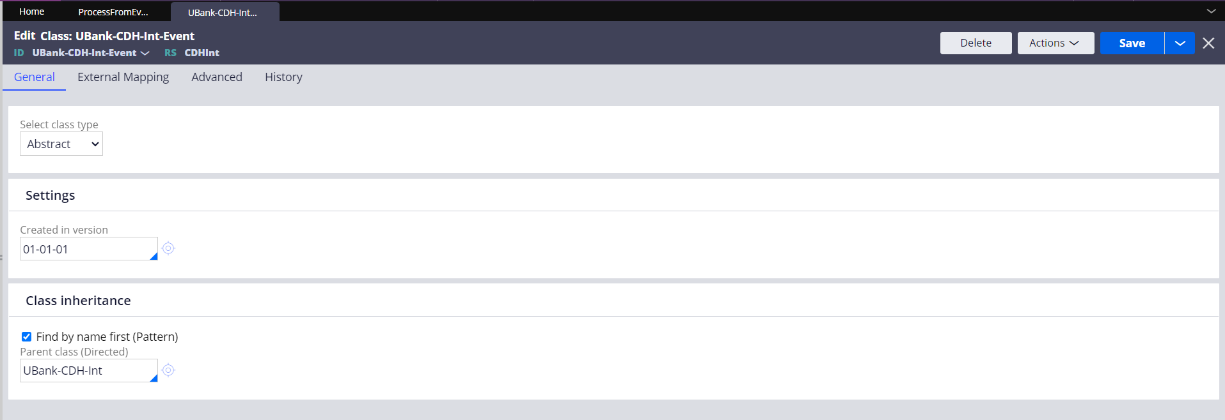

Create Service Package
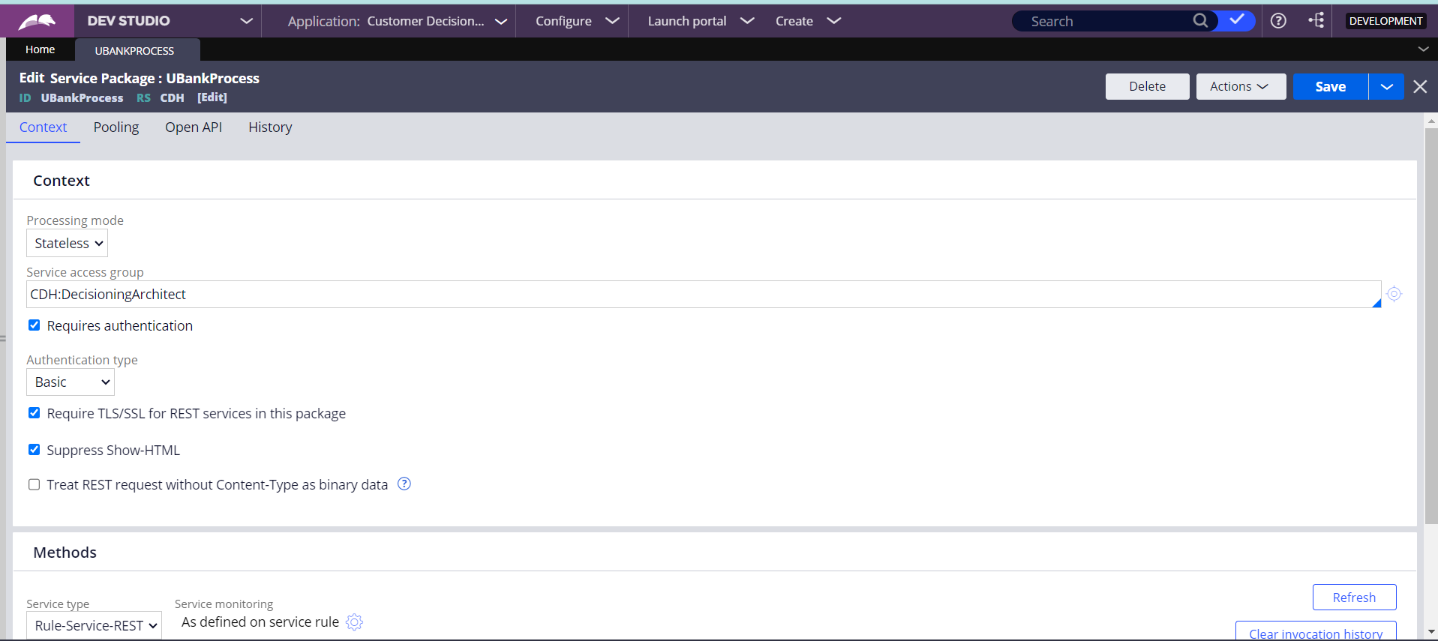

Create Single page Property in Int class
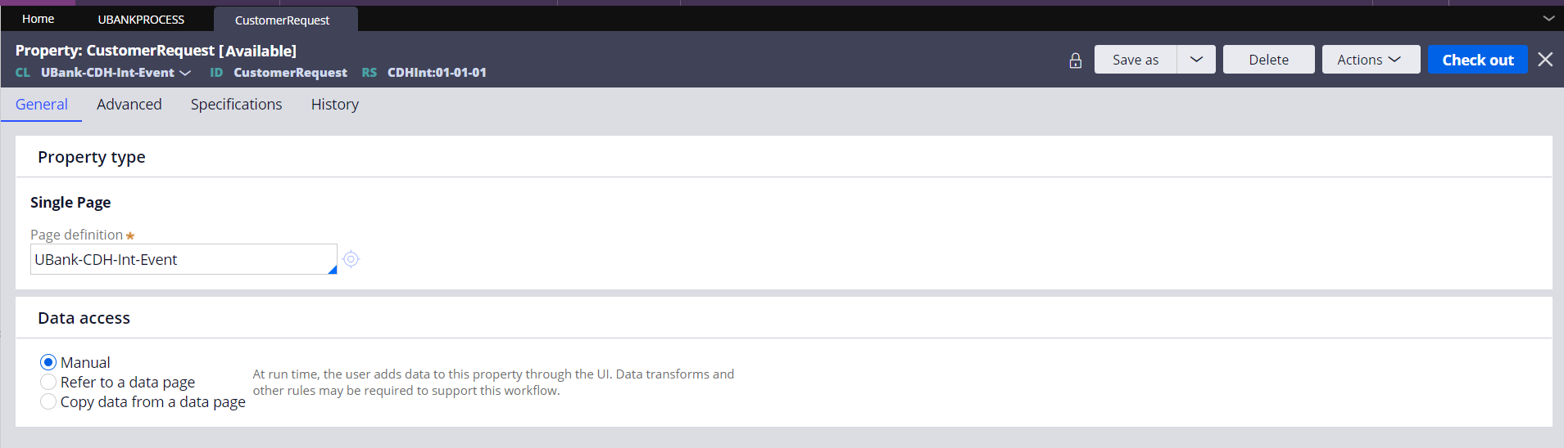
Create Properties in Int Class
Event Name
CustomerID
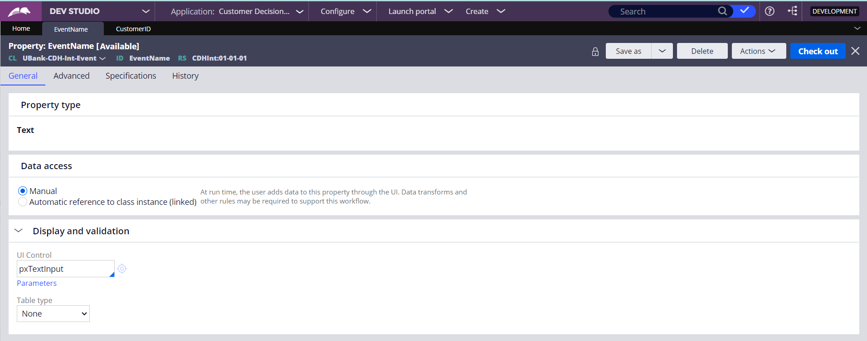

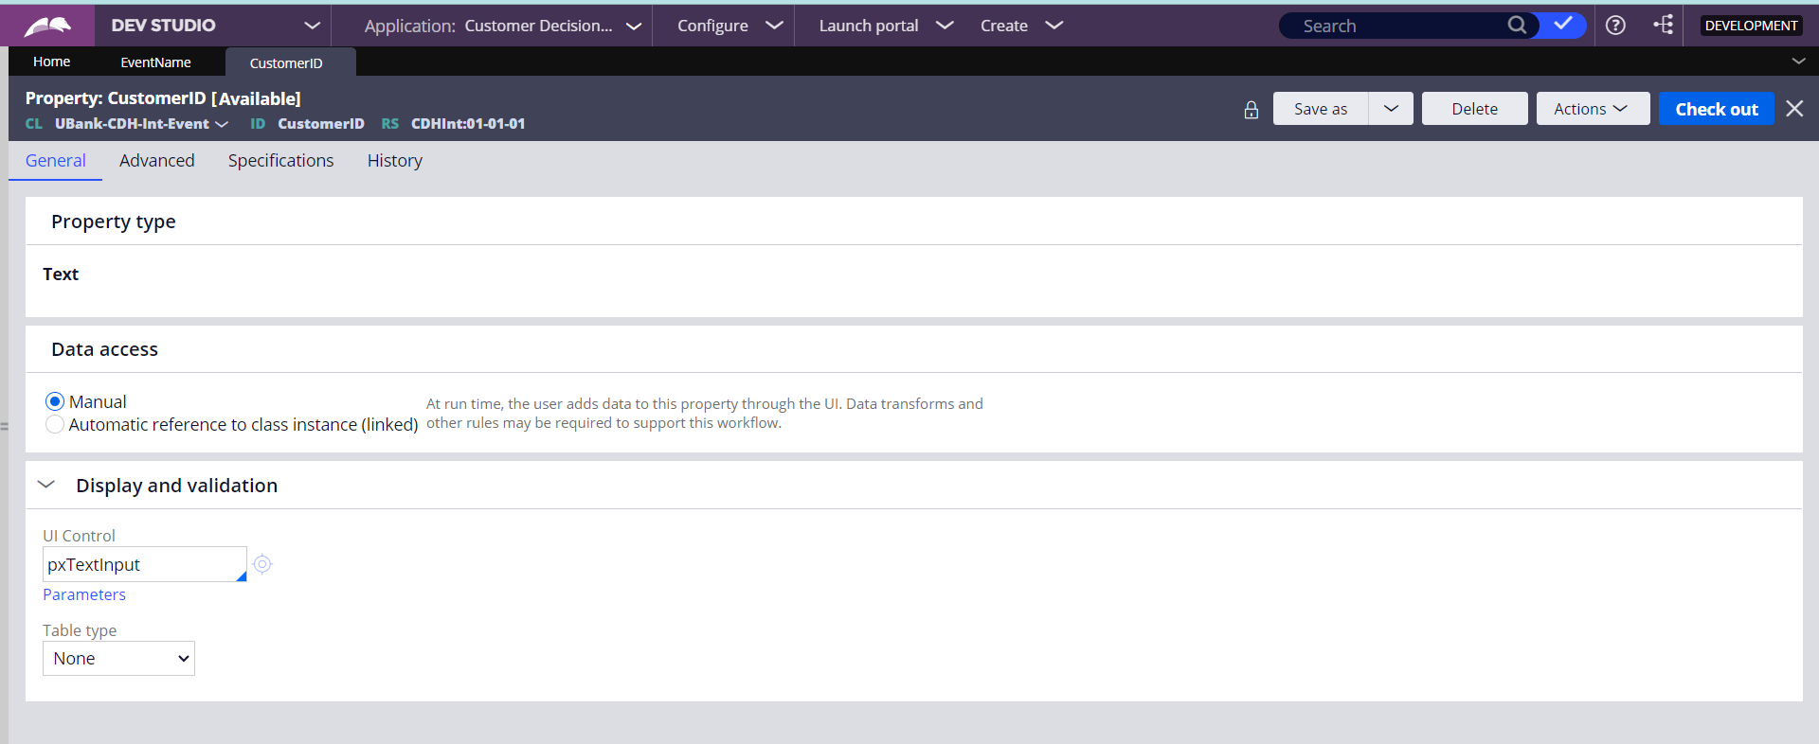

Create Activity in Int Class
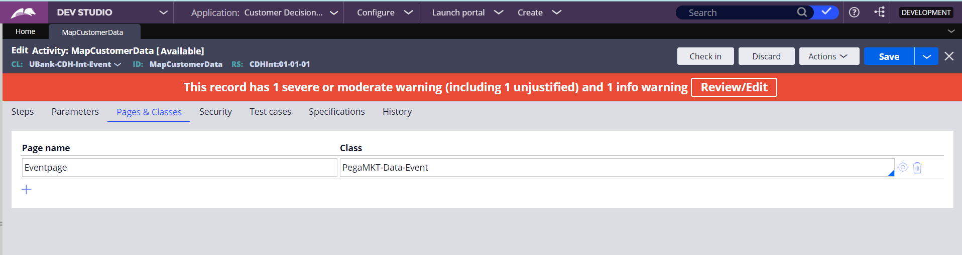

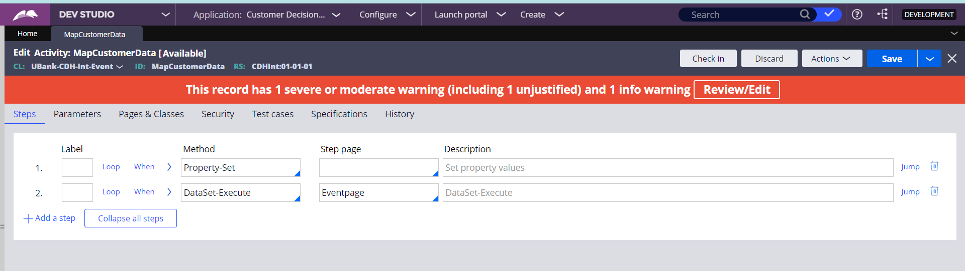
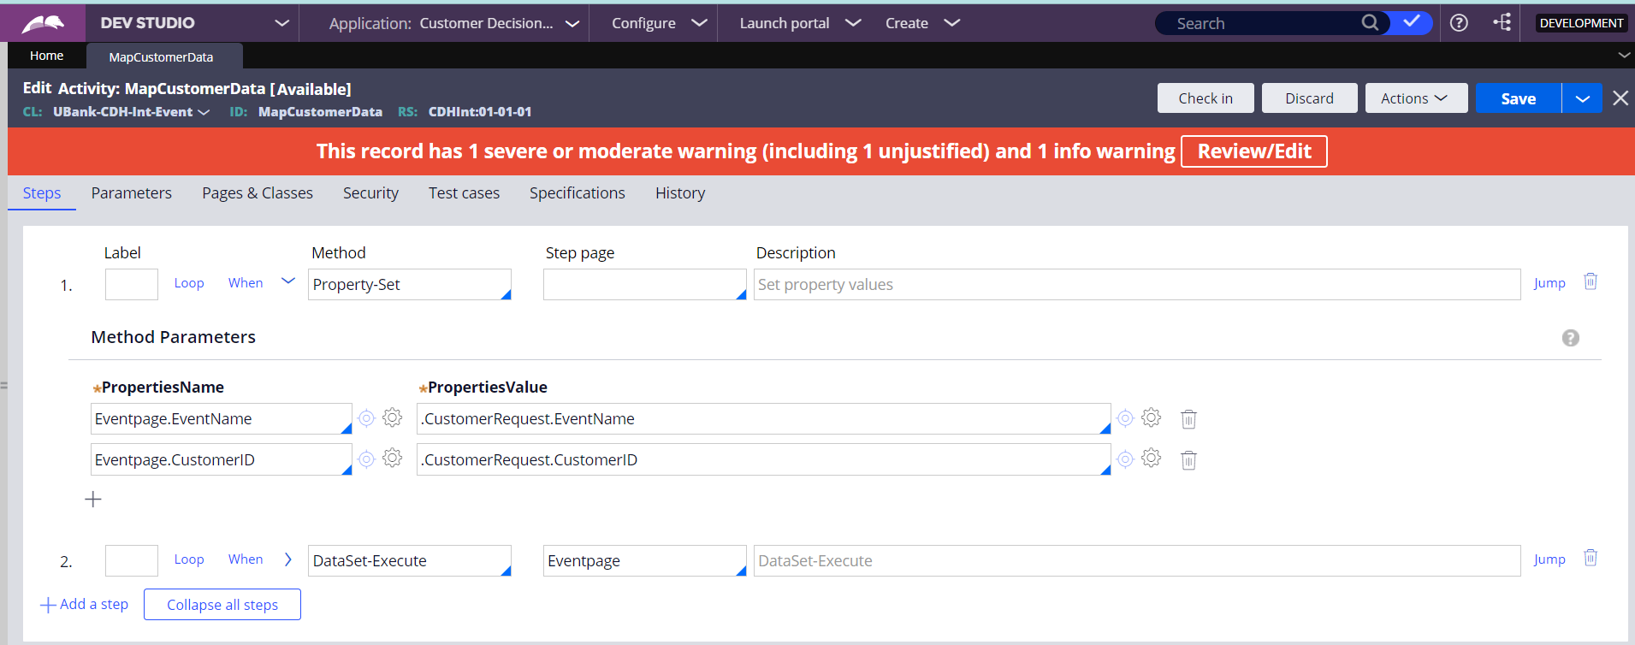

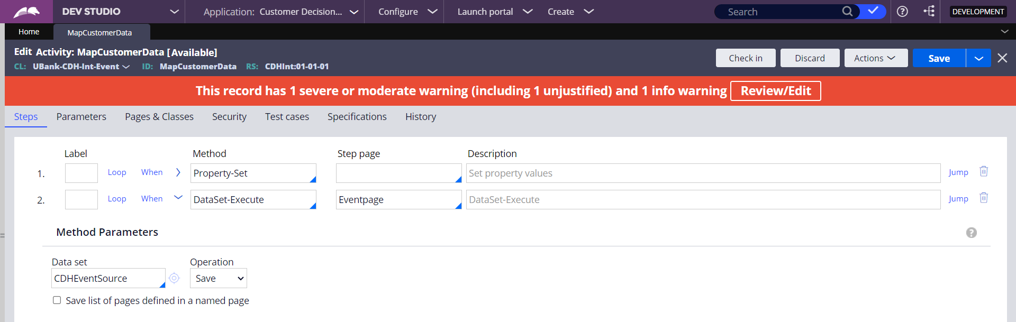

Create REST Service Rule
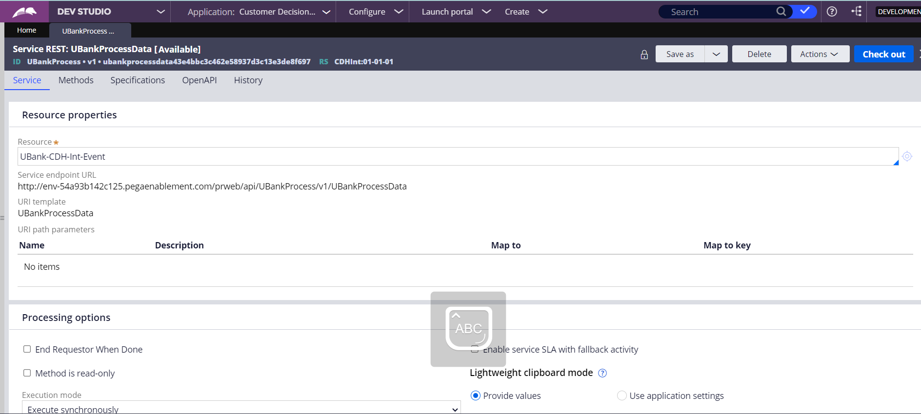

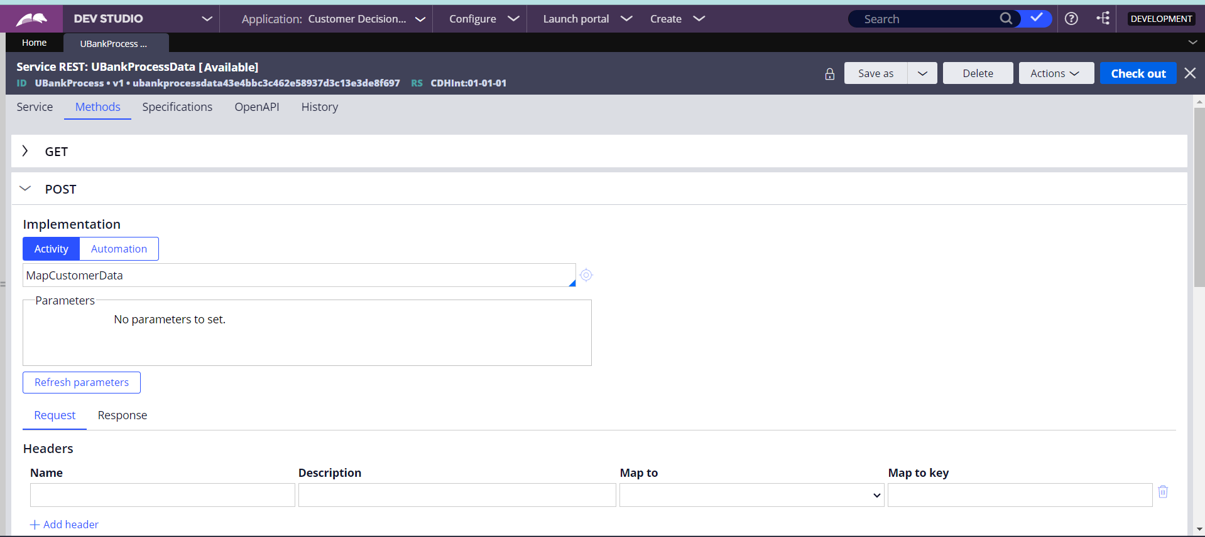

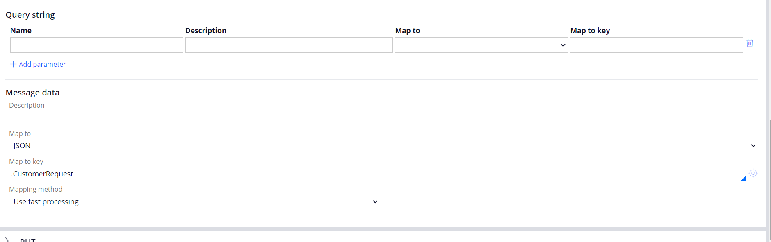

Create Taxonomy

Create Action
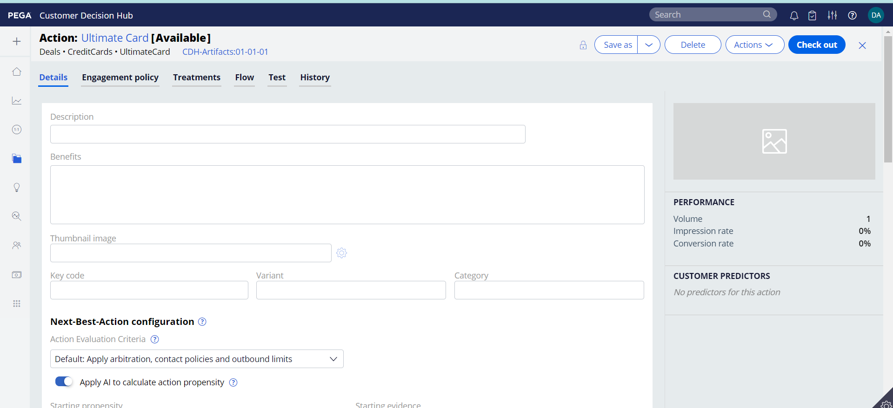

Add Eligibility in Action
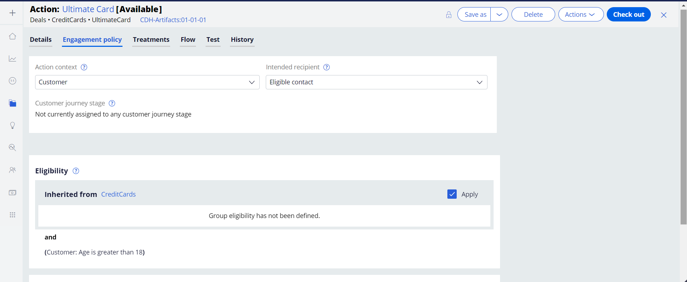

Add Email Treatment ( Existing ) in Action
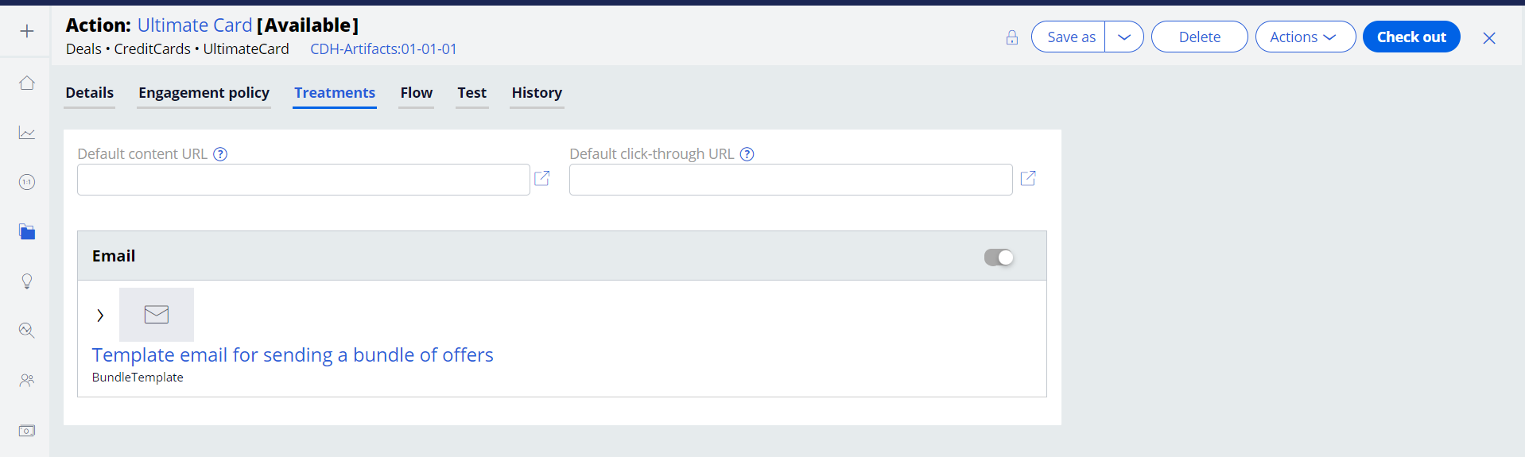

Add offer flow in actions
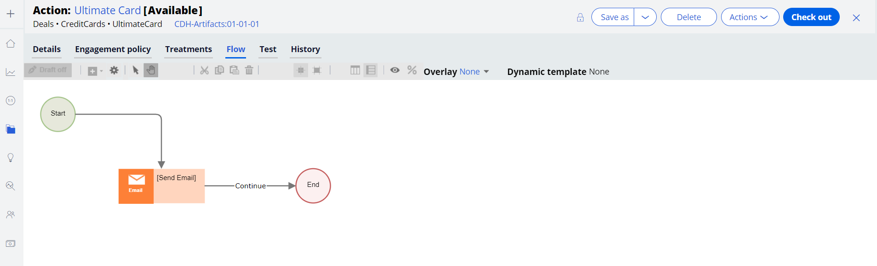

Create Real Time Event

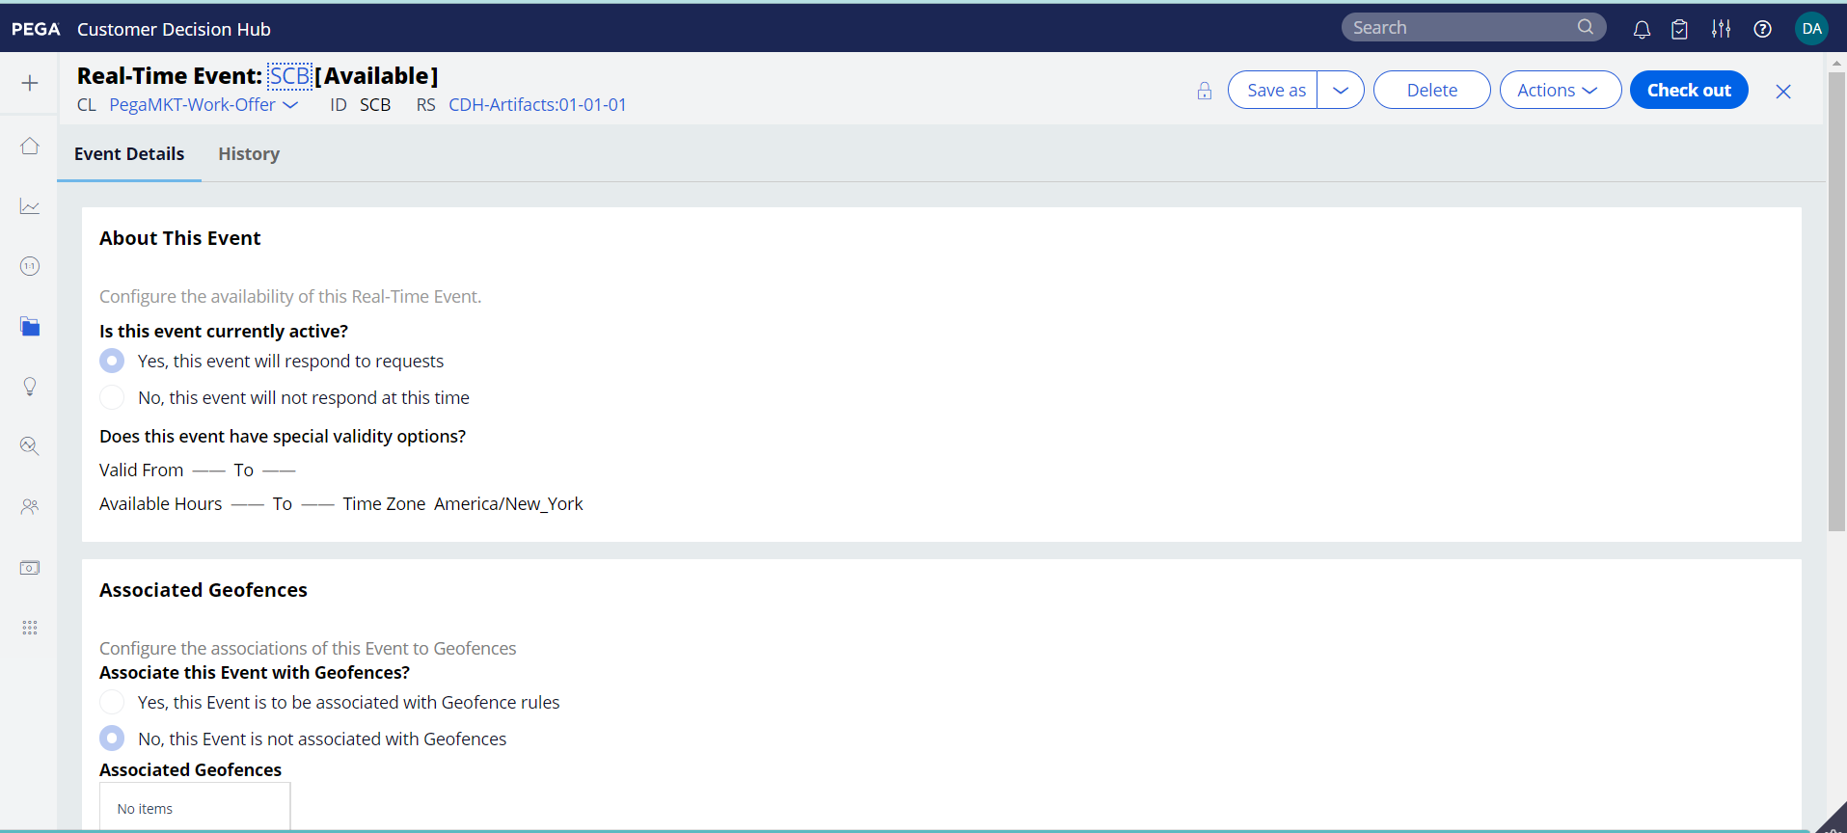

Add Real Time Event in Channels
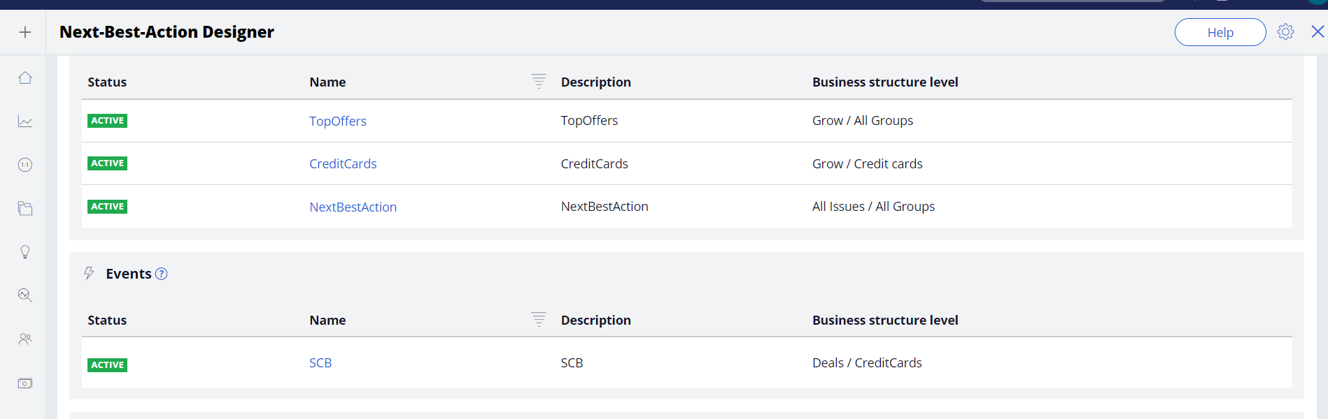

Run the data flow as ProcessFromEventSource
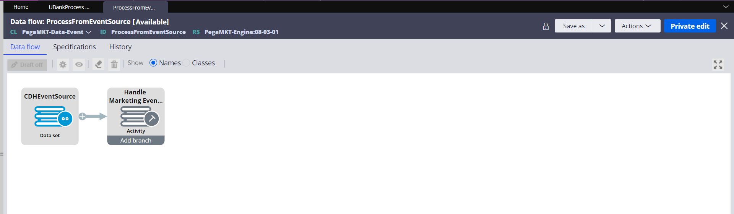

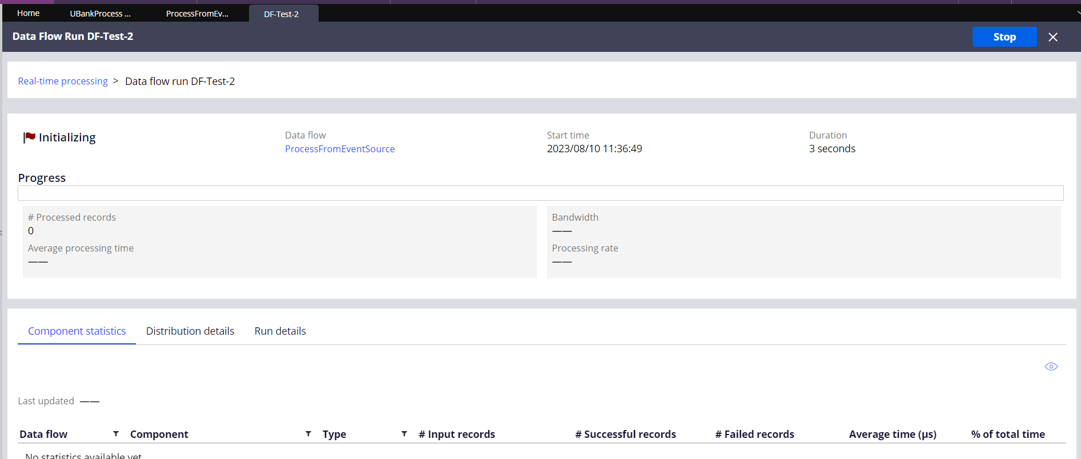

Run the Service
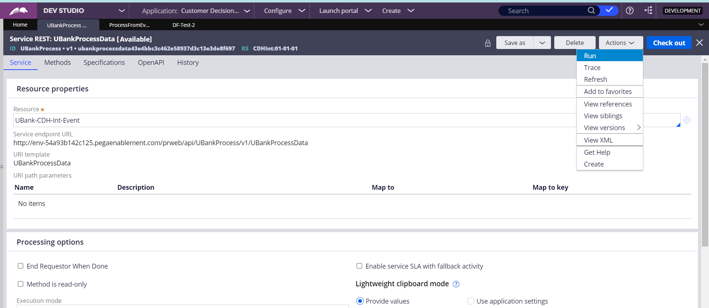

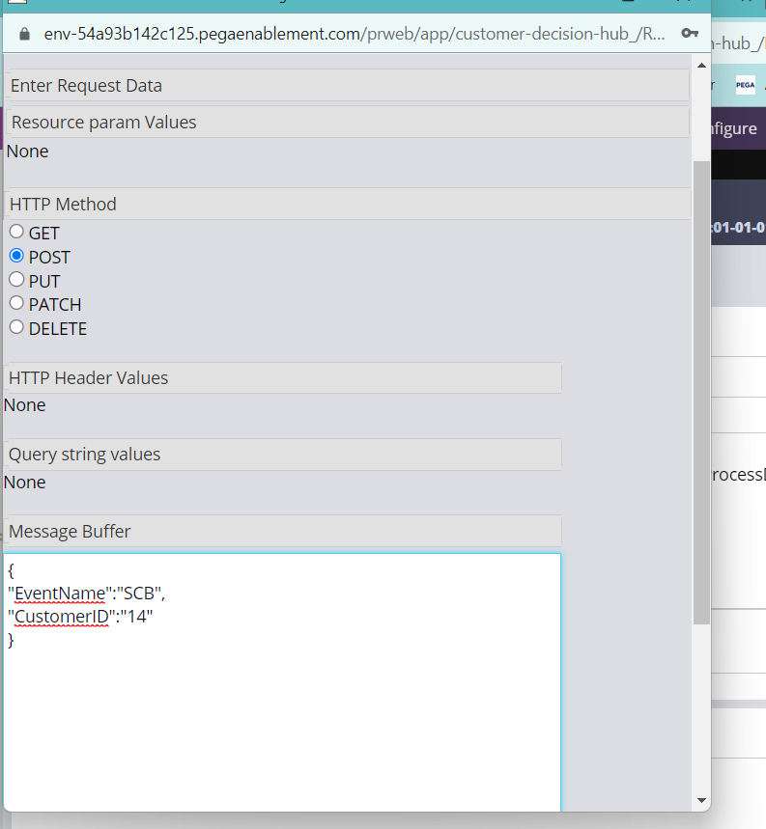

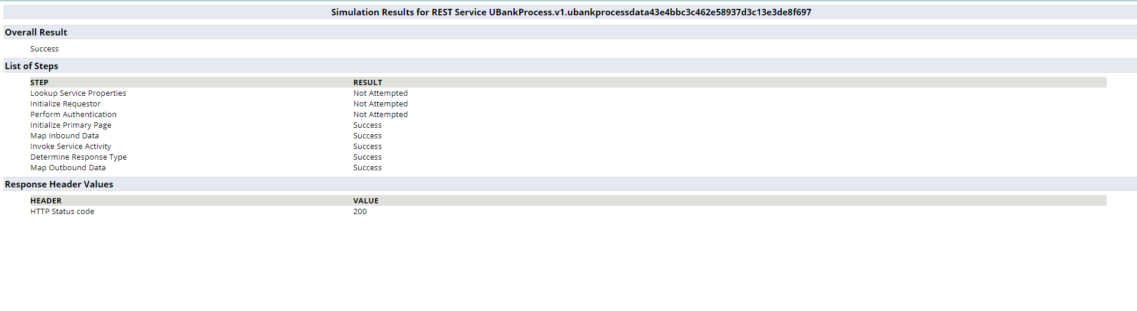

Run the Data as CDHEventSource
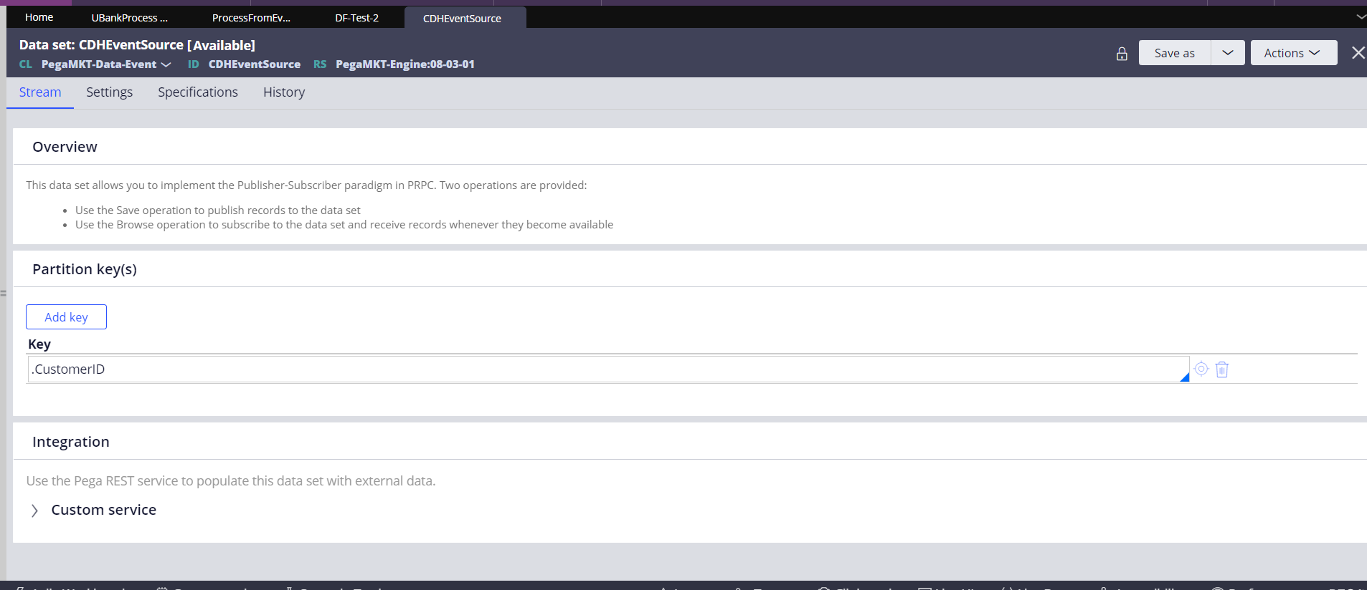

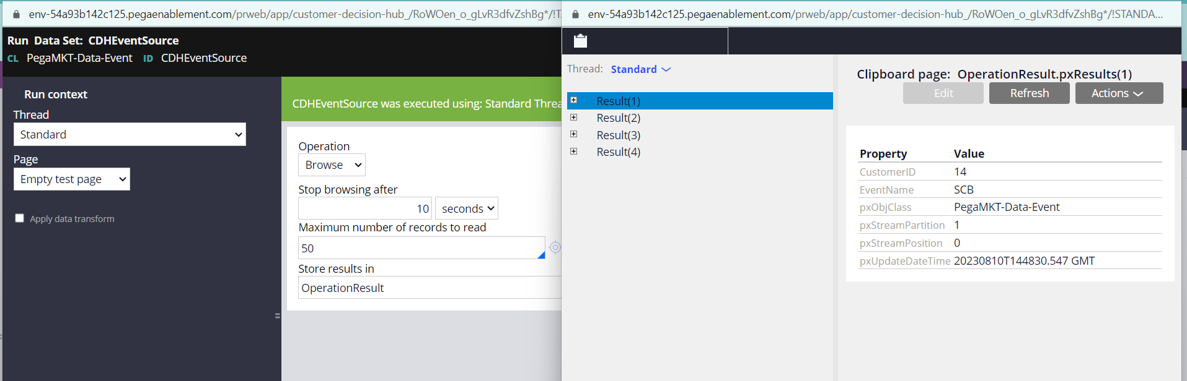

Run the Dataset as pxInteractionHistory
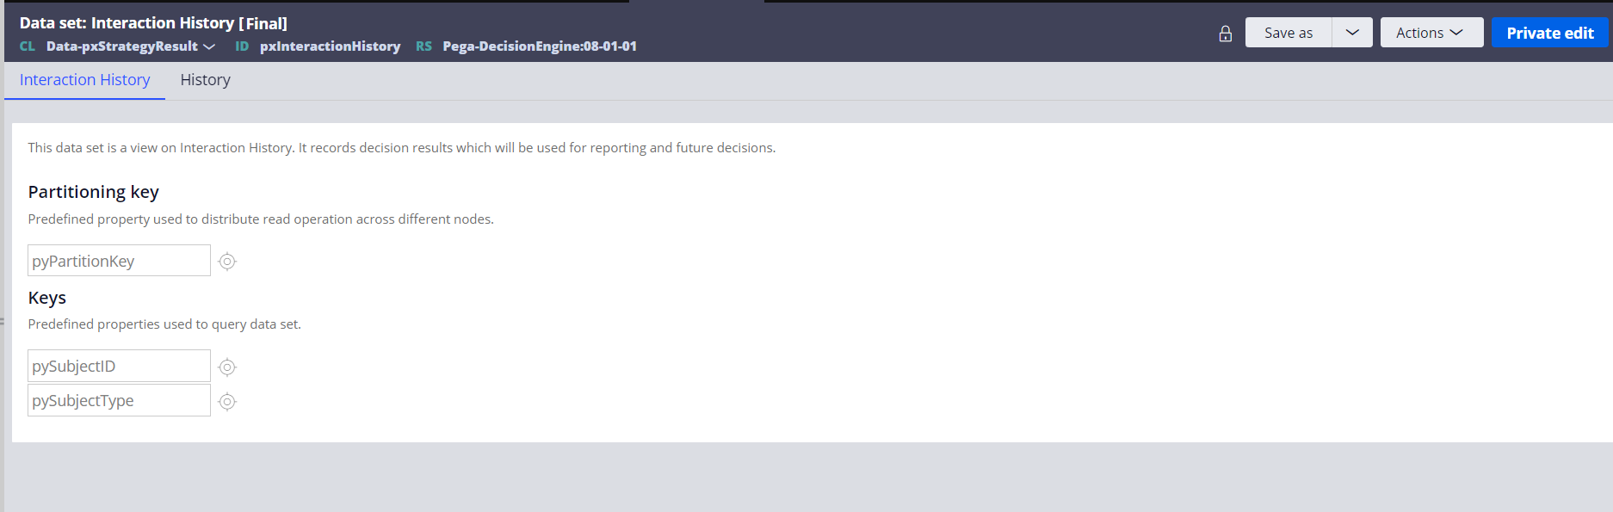

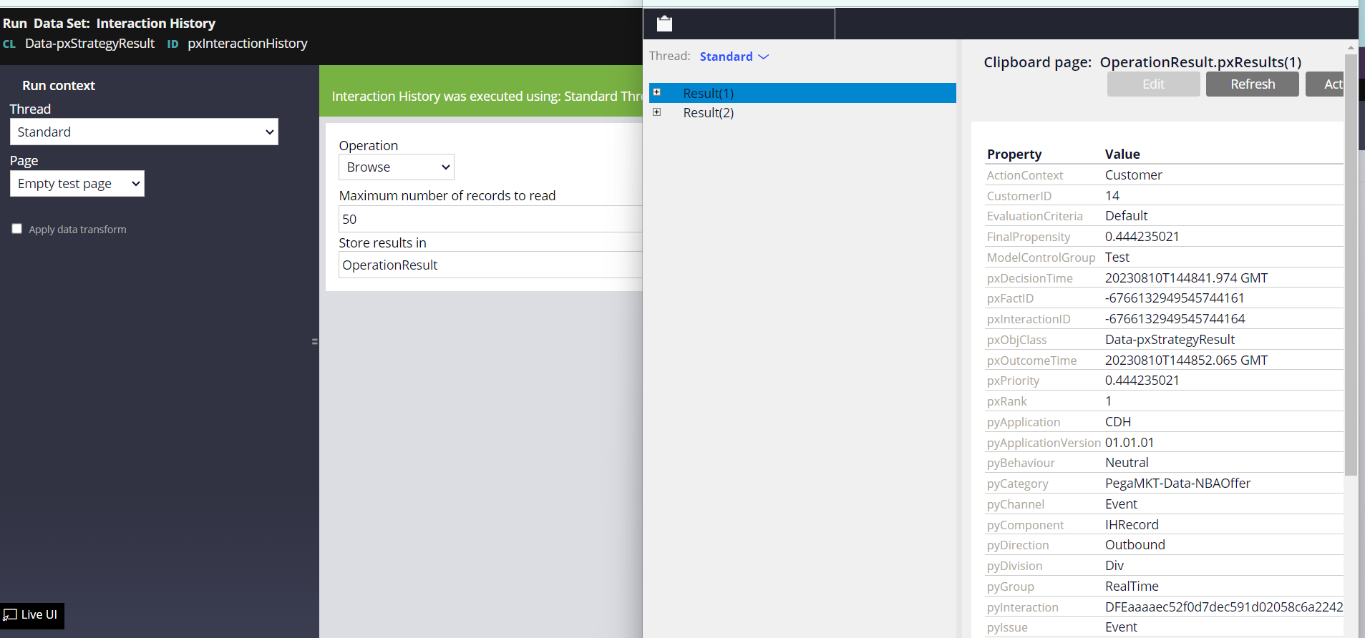

Verify data flow
